

Unemployment problem in the world

[Document subtitle]



**Prepared For :**

**MD**. **Md. Erfan**

**Chairman, Assistant Professor**

**Department of Computer Science & Engineering**

Prepared By:

Most. Sadia Sultana

Roll:28

Batch No.43

Department Of Physics

University of Barishal

December 7, 2024

Table Of Contents

1. Introduction 3

2. Types of Unemployment 3

2.1. Cyclical Unemployment 3

2.2. Structural Unemployment 3

2.3. Frictional Unemployment 3

2.4. Seasonal Unemployment 3

2.5. Long-term Unemployment 3

3. Causes of Unemployment 4

3.1. Economic Factors 4

3.2. Technological Changes 4

3.3. Globalization 4

3.4. Population Growth 4

3.5. Education and Skill Mismatches 4

3.6. Structural Shifts 5

4.Data Representation: 5

5. Effects of Unemployment 7

5.1. Economic Impact 7

5.2. Social Impact 7

5.3. Psychological Impact 7

5.4. Long-term Consequences 8

6. Case Studies 8

6.1. The Great Depression (1929-1939) 8

6.2. The 2008 Financial Crisis 8

6.3. Youth Unemployment in India 8

7.Government Policies and Measures 9

7.1. Employment Generation Programs 9

7.2. Unemployment Benefits 9

7.3. Education and Training Programs 9

7.4. Economic Stimulus Packages 9

7.5. Support for Startups and Entrepreneurs 9

8. Role of Education and Skill Development 9

8.1. Aligning Education with Market Needs 10

8.2. Vocational Training 10

8.3. Lifelong Learning 10

8.4. Bridging the Digital Divide 10

9. Innovative Solutions to Tackle Unemployment 10

9.1. Green Jobs 10

9.2. Gig Economy 11

9.3. Remote Work 11

9.4. Social Enterprises 11

9.5. Microfinance 11

10. Conclusion 11

10. References 12

# 

# **1. Introduction**

Unemployment is a significant social and economic issue affecting people worldwide. It refers to the condition where individuals who are capable and willing to work are unable to find suitable employment. Unemployment not only affects the individuals and their families but also has broader implications for the economy and society as a whole.This project explores the various aspects of unemployment, including its types, causes, effects, and potential solutions.

# **2. Types of Unemployment**

## 2.1. Cyclical Unemployment

Cyclical unemployment is related to the economic cycle. During periods of economic downturn or recession, demand for goods and services decreases, leading to reduced production and job losses.Conversely, during periods of economic growth, unemployment rates tend to fall.

## 2.2. Structural Unemployment

Structural unemployment occurs when there is a mismatch between the skills of the labor force and the demands of the job market.This can be due to technological advancements, changes in consumer preferences, or globalization. Workers may find their skills obsolete and need to retrain for new types of jobs.

## 2.3. Frictional Unemployment

Frictional unemployment is the short-term unemployment that occurs when people are transitioning between jobs, careers, or locations.This type of unemployment is usually temporary and is a normal part of a healthy labor market.

## 2.4. Seasonal Unemployment:

## Seasonal unemployment arises in industries that operate at certain times of the year, such as agriculture, tourism, and construction.Workers in these industries may face unemployment during off-seasons.

## 2.5. Long-term Unemployment

Long-term unemployment refers to individuals who have been unemployed for an extended period, typically over a year. This can lead to skill erosion, decreased employability, and severe financial and psychological impacts.

# **3. Causes of Unemployment**



## 3.1. Economic Factors

Economic recessions, inflation, and fluctuations in demand for goods and services can lead to unemployment.When businesses face lower demand, they cut costs by laying off workers.

## 3.2. Technological Changes

Advancements in technology can render certain jobs obsolete. Automation and artificial intelligence, for example, can replace human labor in manufacturing, services, and even some professional sectors.

## 3.3. Globalization

Globalization has led to increased competition and the outsourcing of jobs to countries with cheaper labor.While this benefits consumers with lower prices, it can result in job losses in certain industries.

## 3.4. Population Growth

Rapid population growth can lead to an oversupply of labor.When the number of people seeking jobs exceeds the number of available positions, unemployment rises.

## 3.5. Education and Skill Mismatches

Inadequate education systems and a lack of alignment between educational curricula and job market requirements can lead to a workforce that is not equipped with the necessary skills.

## 3.6. Structural Shifts

Changes in the economy, such as a shift from manufacturing to services, can result in structural unemployment. Workers in declining industries may struggle to find new employment without retraining.

# **4.Data Representation:**

#### Survey Questions:

#### **1. What is your current employment status?**

* Employed
* Unemployed
* Self-employed
* Student
* Retired

**2. Have you been actively seeking employment in the past 4 weeks?**

* Yes
* NO

**3. What reasons led to your unemployment?**

* Layoff
* Company closure
* Resignation
* Contract ended
* Other reasons

**4. How long have you been unemployed?**

* Less than 1 month
* 1-3 months
* 3-6 months
* 6-12 months
* More than 12 months

#### **5. Have you received unemployment benefits?**

* Yes
* No

**6. Have you experienced age or gender discrimination during your job search?**

* Yes
* No

Survey Data and Responses:

Survey Result Table

Here’s a sample table that could be used for the survey result.

Unemployment by Age Group.

|  |  |  |
| --- | --- | --- |
| Age Group | Unemployment Rate (%) | Change from Last Year (%) |
| 15-24 | 18.2 | +1.5 |
| 25-34 | 9.3 | +0.6 |
| 35-44 | 6.1 | -0.1 |
| 45-54 | 4.9 | -0.2 |
| 55+ | 4.3 | +0.1 |

Changes in the economy, such as a shift from manufacturing to services, can result in structural unemployment. Workers in declining industries may struggle to find new employment without retraining. Rapid population growth can lead to an oversupply of labor.When the number of people seeking jobs exceeds the number of available positions, unemployment rises. Unemployment is a significant social and economic issue affecting people worldwide. It refers to the condition where individuals who are capable and willing to work are unable to find suitable employment. Unemployment not only affects the individuals and their families but also has broader implications for the economy and society as a whole.This project explores the various aspects of unemployment, including its types, causes, effects, and potential solutions

# **5. Effects of Unemployment**

## 5.1. Economic Impact

* **Reduced Consumer Spending**: Unemployed individuals have less disposable income, leading to decreased demand for goods and services, which can further slow down the economy.
* **Loss of GDP**: High unemployment rates can lead to a significant loss in gross domestic product (GDP) as the economy operates below its potential output.

## 5.2. Social Impact

* **Poverty and Inequality**: Unemployment can lead to increased poverty levels and widen the gap between the rich and the poor.
* **Crime and Social Unrest**: High unemployment rates are often correlated with increased crime rates and social unrest as people become desperate and frustrated.

## 5.3. Psychological Impact

* **Mental Health Issues**: Unemployment can lead to stress, anxiety, depression, and a decrease in self-esteem.
* **Family Strain**: Financial instability due to unemployment can strain family relationships and lead to conflicts and breakdowns.

## 5.4. Long-term Consequences

* **Skill Erosion**: Long-term unemployment can result in skill erosion, making it more difficult for individuals to find new employment.
* **Generational Impact**: Unemployment can have a lasting impact on future generations, with children of unemployed parents more likely to experience unemployment themselves.

# **6. Case Studies**

## 6.1. The Great Depression (1929-1939)

The Great Depression was a severe worldwide economic depression that took place mostly during the 1930s. It started in the United States after the stock market crash of October 1929.The resulting economic collapse led to massive unemployment, with the U.S. unemployment rate peaking at around 25%.

## 6.2. The 2008 Financial Crisis

The 2008 financial crisis, also known as the Global Financial Crisis, was a severe worldwide economic crisis that occurred in the late 2000s. Triggered by the collapse of the housing market in the United States, the crisis led to widespread job losses and high unemployment rates globally.

## 6.3. Youth Unemployment in India

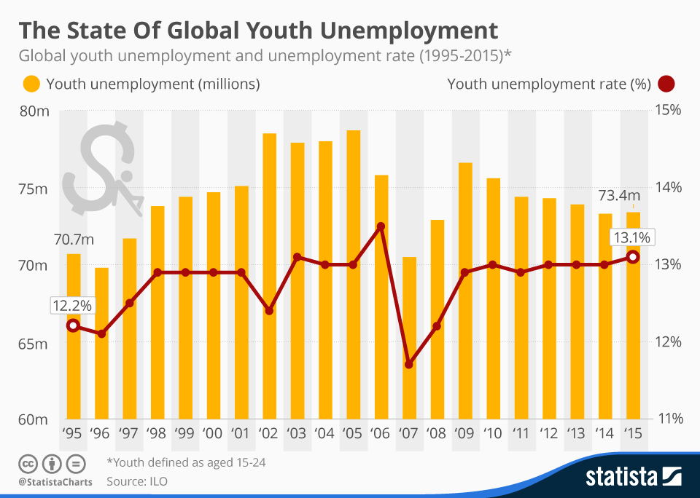

India faces a significant challenge with youth unemployment. Despite economic growth, many young people in India struggle to find employment due to a mismatch between their skills and the demands of the job market. Initiatives like Skill India aim to address this issue by providing vocational training and skill development.

# **7.Government Policies and Measures**

## 7.1. Employment Generation Programs

Governments implement various programs to generate employment, such as public works projects, subsidies for small and medium-sized enterprises (SMEs), and incentives for industries to create jobs.

## 7.2. Unemployment Benefits

Many countries provide unemployment benefits or social security payments to support individuals while they search for new employment. These benefits help alleviate the financial burden and provide a safety net.

## 7.3. Education and Training Programs

Investing in education and vocational training programs helps equip individuals with the skills needed to meet the demands of the job market. Programs that focus on lifelong learning and continuous skill development are essential.

## 7.4. Economic Stimulus Packages

Governments may introduce economic stimulus packages during periods of economic downturn to boost demand and create jobs. These packages can include tax cuts, infrastructure projects, and support for businesses.

## 7.5. Support for Startups and Entrepreneurs

Encouraging entrepreneurship and supporting startups can lead to job creation and innovation. Governments can provide grants, tax incentives, and access to capital to foster new businesses.

# **8. Role of Education and Skill Development**

## 8.1. Aligning Education with Market Needs

Educational institutions must align their curricula with the needs of the job market. This involves collaboration between industries and educational institutions to ensure that students acquire relevant skills.

## 8.2. Vocational Training

Vocational training programs provide practical skills and hands-on experience, making individuals more employable. These programs can focus on trades, technical skills, and other job-specific competencies.

## 8.3. Lifelong Learning

Encouraging a culture of lifelong learning ensures that individuals continue to update their skills throughout their careers. This can be facilitated through online courses, workshops, and professional development programs.

## 8.4. Bridging the Digital Divide

Access to digital tools and technologies is essential for modern job markets. Ensuring that all individuals have access to digital education and training can help bridge the gap and reduce unemployment.

# **9. Innovative Solutions to Tackle Unemployment**

## 9.1. Green Jobs

Promoting jobs in the green economy, such as renewable energy, energy efficiency, and environmental conservation, can create new employment opportunities while addressing environmental issues.

## 9.2. Gig Economy

The gig economy, which includes freelance and short-term contract work, offers flexible employment opportunities. Platforms like Uber, TaskRabbit, and Upwork have created new avenues for income.

## 9.3. Remote Work

Advancements in technology have made remote work more feasible. Encouraging businesses to adopt remote work policies can create job opportunities for people regardless of their geographical location.

## 9.4. Social Enterprises

Social enterprises focus on creating social impact alongside profit. Supporting social enterprises can lead to job creation in underserved communities and sectors.

## 9.5. Microfinance

Providing microfinance services to small businesses and entrepreneurs can help them start or expand their ventures, leading to job creation at the grassroots level.

# **10. Conclusion**

Unemployment is a multifaceted issue that requires a comprehensive approach to address effectively.By understanding the types, causes, and effects of unemployment, and implementing targeted policies and innovative solutions, we can work towards reducing unemployment rates and improving the quality of life for individuals and communities.Education, skill development, and government intervention play crucial roles in this endeavor, and a collaborative effort is essential to create a sustainable and inclusive job market. However, it was a time of high unemployment in all other major industrialised nations as well.[[147]](https://en.wikipedia.org/wiki/Unemployment#cite_note-147) By the spring of 1983, unemployment had risen by 6% in the previous 12 months, compared to 10% in Japan, 23% in the US, and 34% in [West Germany](https://en.wikipedia.org/wiki/West_Germany) (seven years before [Reunification](https://en.wikipedia.org/wiki/Reunification_of_Germany)).[[148]](https://en.wikipedia.org/wiki/Unemployment#cite_note-148)

# 

# **11. References**

* [ILO – International Labour Organization](https://www.ilo.org/)
* [World Bank Reports](https://www.worldbank.org/)
* [OECD – Organisation for Economic Co-operation and Development](https://www.oecd.org/)
* National Sample Survey Office (NSSO) Reports
* Books on economics and labor markets
* Research papers and journal articles on unemployment
* Farmer, Roger E. A. (2001). "Unemployment". Macroeconomics (Second ed.). Cincinnati: South-Western Publishing. pp. 173–192. ISBN 978-0-324-14964-7.
* Kalecki, Michał (1943). "Political aspects of full employment" (PDF). The Political Quarterly. 14 (4): 322–331. doi:10.1111/j.1467-923X.1943.tb01016.x.
* McGaughey, Ewan (September 2022). "Will Robots Automate Your Job Away? Full Employment, Basic Income, and Economic Democracy". (2022) 51(3) Industrial Law Journal 511–559. doi:10.2139/ssrn.3044448. S2CID 219336439. SSRN 3044448.
* Reich, Robert B. (2010). Aftershock: The Next Economy and America's Future (1st ed.). Alfred A. Knopf. ISBN 978-0-307-59281-1
* Romer, David (2011). "Unemployment". Advanced Macroeconomics (Fourth ed.). New York: McGraw-Hill Education. pp. 456–512. ISBN 978-0-07-351137-5.
* Simonazzi, Annamaria; Vianello, Fernando (2001). "Financial Liberalization, the European Single Currency and the Problem of Unemployment". In Franzini, M.; Pizzuti, F. R. (eds.). Globalization, Institutions and Social Cohesion. Heidelberg: Springer. ISBN 978-3-540-67741-3